**Milestone 1**

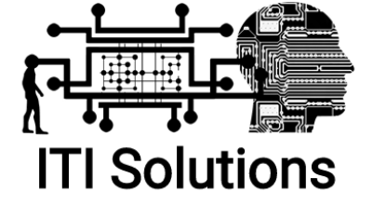

Justin Alho Harley Lenton Aidan Campbell

Evan Guest Beryon Clark

September 30, 2019

Edenbridge Time Tracking and Scheduling Project

Software Name: Schedule ED

Client: Edenbridge Family Services

Client Contact: Rachel Frantz

**Client Signature:** _________________________________________ **Date:** ____________

**Table of Contents**

**TEAM INTRODUCTION.........................................................................................................1**

**CLIENT INTRODUCTION......................................................................................................2**

**PROJECT DESCRIPTION.......................................................................................................3**

**PROJECT REQUEST....................................................................................................3**

**FEASIBILITY.................................................................................................................4**

**PROFESSIONAL WORKING STANDARDS........................................................................6**

**Team Introduction**

“Achieve Maximal Efficiency”

Our team, known as “ITI Solutions”, will be undertaking a project for Edenbridge Family Services which will be detailed later in this document. At time of writing, the team members and their roles are as follows:

* Aidan Campbell – [aidan.campbell@lethbridgecollege.ca](mailto:aidan.campbell@lethbridgecollege.ca) | (403)-330-7173
  + Team Leader
* Harley Lenton – [harley.lenton@lethbridgecollege.ca](mailto:harley.lenton@lethbridgecollege.ca) | (587)-220-8730
  + Liaison Officer
* Beryon Clark – [beryon.clark@lethbridgecollege.ca](mailto:beryon.clark@lethbridgecollege.ca) | (403)-915-6855
  + Server Engineer & Administrator
  + User Experience Development
* Justin Alho – [justin.alho@lethbridgecollege.ca](mailto:justin.alho@lethbridgecollege.ca) | (587)-257-0291
  + Programming
  + Database Development
* Evan Guest – [evan.guest@lethbridgecollege.ca](mailto:evan.guest@lethbridgecollege.ca)
  + Programming
  + User Experience Development

Each member will have their own focuses but will assist in other tasks as deemed necessary by other team members. Essential decisions will be determined by overall team vote with majority rules in place, with the leader’s decision overriding in the event of conflict or stalemate with members present.

**Client Introduction**

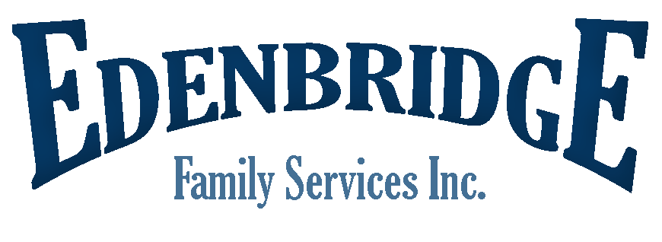

As mentioned, the client we will be taking on for this project is Edenbridge Family Services. Edenbridge is a government funded organization that contracts individuals to assist people with disabilities in a multitude of ways. Our point of contact and sponsor of this project with Edenbridge is Mrs. Rachel Frantz. The main channel of communication with the client will be Harley Lenton, the liaison officer. We have already conducted our initial meeting with Rachel to gather information on the project request and some initial analysis on the current system that is to be replaced.

Edenbridge Family Services’ location and contact information:

* #100 316 – 13 Street South, Lethbridge, Alberta T1J 2V6
* Phone: (403)-320-8887
* Fax: (403)-320-9887

Mrs. Rachel Frantz’s contact information:

* E-Mail: [rachel@edenbridge.ca](mailto:rachel@edenbridge.ca)
* Phone: (403)-320-8887

**Project Description**

**Project Request**

**Current System:** At present, the system at Edenbridge is a combination of handwritten forms, manual data entry, and manual exporting from spreadsheets. At the start of the process, employees fill out timesheets, then sign and submit them. Afterwards, they are entered into several Excel tables, with each table having to be manually filled in. From there, requisite data is manually exported from Excel into the accounting software Edenbridge uses, Simply Accounting.

**Business Problem:** The system currently implemented at Edenbridge has a variety of issues, ranging from minor annoyances to significant cost-inducing errors. Overall, the system tends towards the end of inefficiency, with occasionally multiple hours or even entire days being devoted to a single task. The data itself is complicated to sift through with employees each undertaking multiple categories of work and several levels of pay associated with each category. Additionally, the complexity of the data is such that few people at Edenbridge are properly versed in how to properly sort the data. The manual timesheets present another issue: inaccuracies in the data inputted. Occasionally, employees will fill out and submit timesheets before the end of their shift or current period of work. This inevitably leads to inaccuracies in the data input into the system and creates issues where the employee will not be able to complete the work that they have reported. In many such cases, this leads to the employee in question to be paid for work they never accomplished or paid the wrong amount for the type of work they have done.

**Expected Benefits:** The system the client is requesting is expected to make the currently arduous process of data entry and management far simpler and more efficient. The most significant benefit will be time-per-task to be reduced significantly and thus allow employees to devote more time to other tasks in need of completion. In doing so, it is also expected that the system will reduce the number of errors to a minimum.

**Feasibility**

**Technical Feasibility:** The physical infrastructure at Edenbridge as mentioned before is a mix of computerized systems and physical paper forms such as timesheets. With the computers, they are divided up with numerous computers currently running Windows 7 and slated to be upgraded en masse to Windows 10. In addition, they have a server running Windows Server 2016. In terms of software, the two most significant programs they utilize now are Microsoft Office Excel and Simply Accounting.

For the proposed system, we will be able to take advantage of much of the pre-existing hardware. It is possible that paper timesheets may need to remain a part of the system but if they cannot be completely digitized, the amount of information required to be transferred can be reduced. Software will likely not be an issue, as Office programs are designed to be compatible on a wide variety of hardware configurations. Interfacing the proposed system with Simply Accounting however is an unknown process as of yet and may very well present a long-term issue. The main constraint is the need for a legally binding way for employees to confirm the hours they have worked, but there are ways to accomplish this.

**Economic Feasibility:** With regards to economic feasibility, this project will have minimal cost to the client. Because the project does not have any associated up-front cost and at maximum minor long-term costs, the break-even point and return on investment is realized close to the date of delivery and installation. As noted with the technical feasibility, there are components of the system that will be compatible and will assist in bringing down costs related to the system considerably. At the time of delivery, the system should be able to assist Edenbridge with saving costs in operations and reducing errors which can cost the organization considerable amounts of money. Much of the long-term costs associated with the system will be a result of services utilized such as SignRequest.

**Organizational Feasibility:** With the proposed system, users will have to be trained in how to use the system. This will include demonstrating the differences between the old and new systems, demonstrating how to troubleshoot minor problems with the system, and providing source code to Edenbridge in the event they require modifications to the system after delivery. They will also be provided documentation with the source code to assist in understanding each component of the final system.

**Feasibility Summary:** Overall, the proposed system as it is presented currently is well within the scope of the request and is ultimately feasible to build. Edenbridge as a client appears to be comfortable with adopting new systems and technologies. The system as proposed has near zero up-front costs and minimal long-term costs, in large part to our services not resulting in a financial cost to the client. The compatible components such as the Windows server also assist in bringing down the total cost of the system. While the overall flow of the system as proposed will heavily differ from Edenbridge’s current system, it will allow for a relatively simpler time utilizing it.

**Professional working standards**

We will gather as much information as we can about how the business currently operates by asking as many questions as we reasonably can. If necessary, we will pursue more specific information with follow-up questions designed to ascertain a deeper degree of clarity either about the proposed system or aspects of the current system. We will observe some operations of the business, communicating with the client the best we can. Overall, this should give us a reasonable degree of insight into the company’s processes.

The development process will be achieved using the waterfall methodology. Extensive research and analysis will be conducted while communicating with the client to discuss options before moving on to design the system.

We will design any databases required for the project and as per project requirements states, ensure that they are hosted on servers accessible to the client while maintaining standards of privacy. In addition, we will write requisite software that is not currently available to be utilized and provide documentation for the software and the overarching system. Finally, we will train employees of Edenbridge to ensure they possess an adequate understanding of how to operate the system.

We will do the best we can to communicate all the things necessary to properly use the system. It may help to have someone from outside of the group do a usability test to give feedback on whether the system is user friendly.

The project selection is to be well defined by September 30th. The scope of the project should be settled on by October 14th. Modeling our processes is to be achieved by October 28th. By November 18th, we should have our database properly modeled. By November 30th, we will have a full feasibility analysis completed along with a recommendation for a system for the client to agree on. In late January, the data structure used in the database should be designed. The user interface and physical architecture should be done by mid-February. In late March, all coding and testing will be completed. At the end of March, the training plan will be formulated along with all the documentation for it. Finally, in mid-April the software will be installed on the client’s hardware and the client will be trained in its use, and a summary of the system will be shown off in a final presentation.